This is a comic store simple website and database project. In order to achieve the purpose of the website, I recreated and changed the database file from the original one. I know there are a lot of details that can be improved. This project is just the simplest, most basic model for T3 system.

This project includes:

Buyorder.php

A background php file for insert the order information into bookshelf table.

Conn.php

The common file for every php file connects to mysql database.

Exit.php

Clean user information and log out.

Guestbook.php

A php file also has background function which inserts the user comment into guestbook table

Header.php

The main menu on the top which is always included in every page

Index.php

The main page for user login

Info.php

For user to change their password

Login.php

A php file shows user login

OrderList.php

A php file for query from database also has delete function

Reg.html

Registration page

Reg.php

A background php file for registration

Reserve.php

A php page which has js code for user view and select books to order.

Create.sql

The database source

Img folder

The books’ cover images.

**Introduction Part:**

First when you get all these files, please move them to C:\xampp\htdocs\ (any folder).

Then install your XAMPP, in my case, I’m using XAMPP v3.2.1. This decides the PHP version, very important; and MySQL 5.5.25. Once XAMPP is installed, run it and start both Apache and MySql Services.

You will see Apache is running and Mysql is running at the console panel.

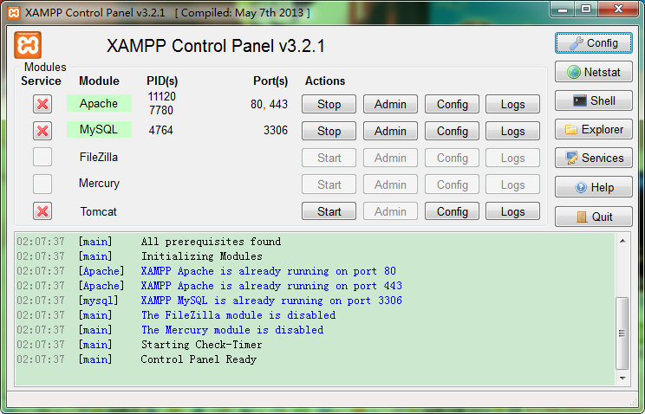

Next, start MySql command line, use Create.sql to create our database.

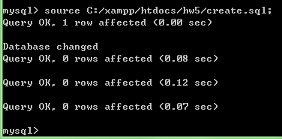

This database is just a simple database for some function of our store, so I made a new one which has only three useful tables inside. They are now empty.

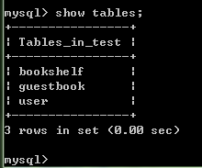

After creating a database in your MySql, you have to edit “conn.php” which includes MySql connection information. Change the password to your password:

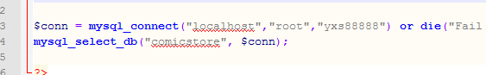

Now you may open your browser and type in <http://localhost/hw5/index.php> (hw5 is my folder)

Then start your using of our website and datebase.

**How to Use:**

First of all, you need to register an account for view our website:

As you are new user, click  for registration.

Fill in the forms.

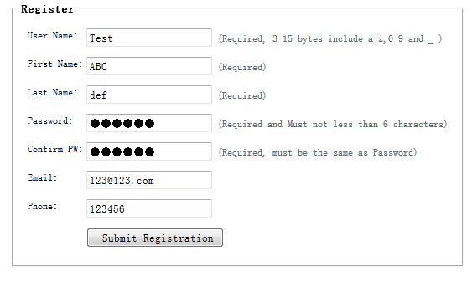

When you finish this, please check mysql command line. You will find the new user’s info.



Then login.

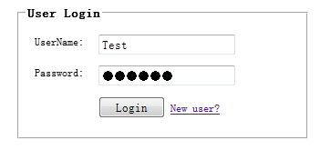

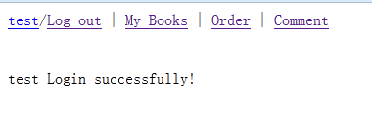

My Books shows the history that what book you bought

Order is to buy book online

Comment is to report anything to us

As you don’t have any book now. “My books” is empty. Please go to “Order” Page.

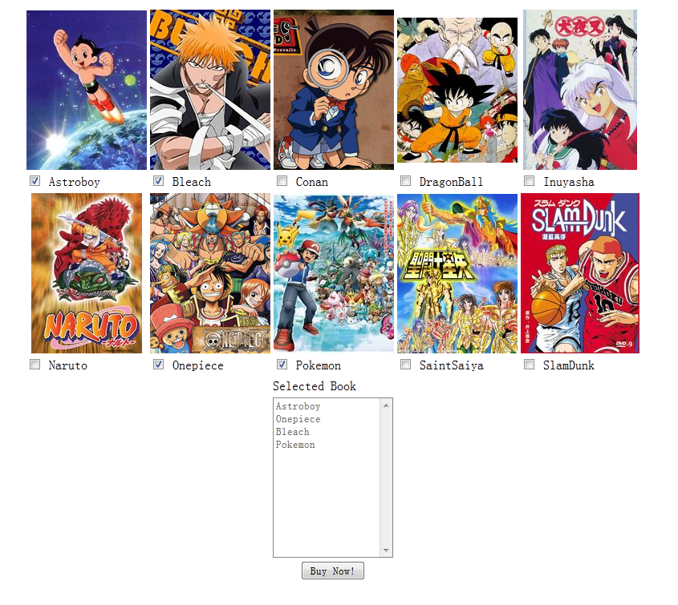

You choose four books and click buy now. You will see:



Then go back to “My Books”, you will find:

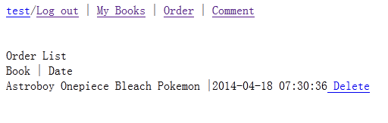

Let’s check it in mysql command line:

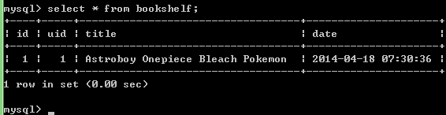

If you want to leave message to us, please click Comment page:

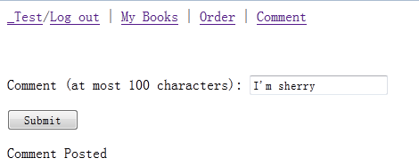

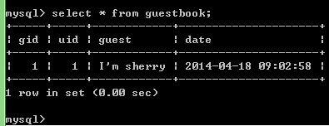

**Change Your Password:**

Click on your name after you login.

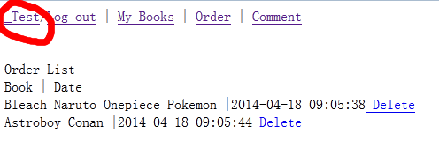

Then follow the instruction to change your password.